CTM-I Use Case

Parm Definition Browse

Version 0.1

Use Case Name | Parm Definition Browse
Actor | App Support
Pre-conditions /Assumptions | User has Browser and is aware of the http path to the application.  User has successfully logged into the CTM-I application.  User has the right role to see the menu options.
Post Conditions | None
Screenshot | 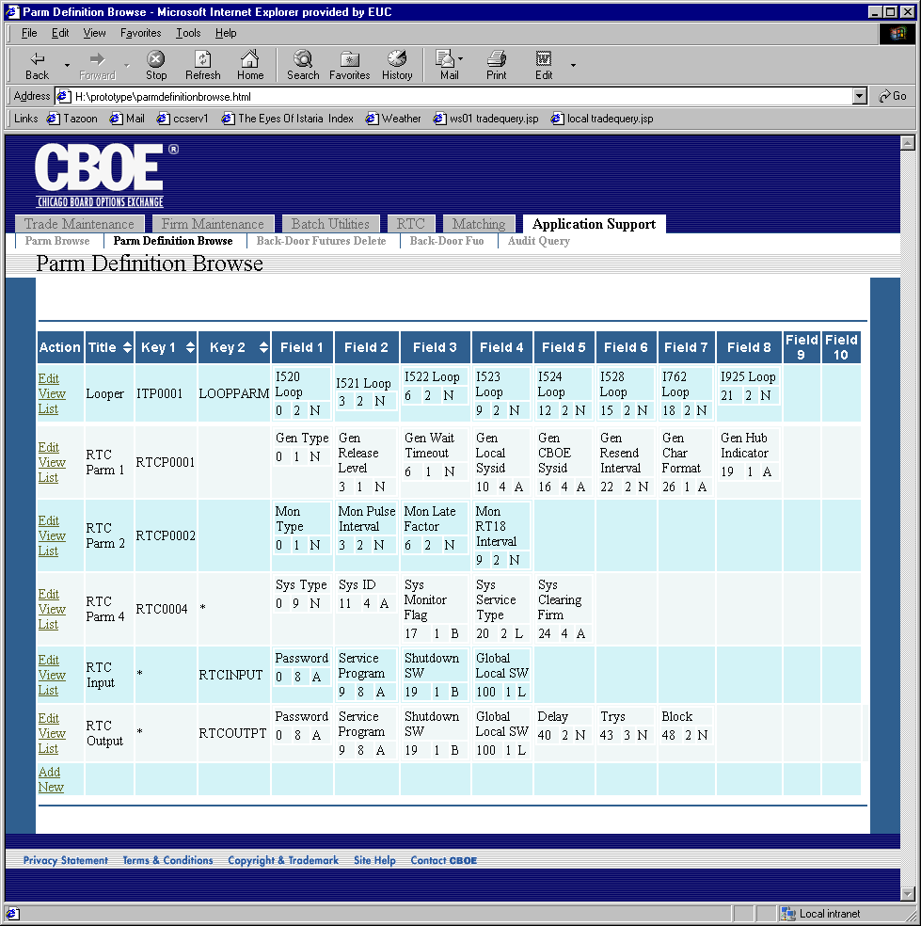
Flow of Events | - User selects “Parm Definition Browse” from the menu.  - The list of Parm Definitions is retrieved from CTM-R  - The Parm Definition Browse screen is show, with all the Parm Definitions in a table.  - All results will show in the table, no paging will be available  - All fields in the table are read-only  - The fields in the table will be  - Title  - Key 1  - Key 2  - Field 1 thru Field 10  - Each field cell will display the Title, Start Column, Length and Type of the field.  - An action to edit the Parm Definition will be available on each row. Activating this will trigger the Parm Definition Edit Use Case.  - An action to delete the Parm Definition will be available on each row. Activating the delete will first cause a confirmation prompt to show. After confirmation, a request will be sent to CTM-R to delete the Parm Definition. The screen will then refresh with the new list of Parm Definitions.  - An action will be available to add a new Parm Definition. This action will trigger the Parm Definition Add Use Case.  - An action will be available to view the list of Parms that match the criteria of the Definition. This action will be on each row. The action triggers Dynamic Parm Browse Use Case.
Alternative Path

